Jennifer Lombardi
MTH 4040: Hands on Activity
Dr. Fothergill
5/3/17
Statistics with M&M’s

Goals: Students will use their knowledge of statistics to compute mean, standard deviation, and z-score using the weight of 10 packets of M&M’s.
Objectives: Given 10 packets of M&M’s, students will weigh each packet and compute the mean, standard deviation, and z-score.
NYS Common Core Standards
Summarize, represent, and interpret data on a single count or measurement variable
CCSS.MATH.CONTENT.HSS.ID.A.1
Represent data with plots on the real number line (dot plots, histograms, and box plots).
CCSS.MATH.CONTENT.HSS.ID.A.2
Use statistics appropriate to the shape of the data distribution to compare center (median, mean) and spread (interquartile range, standard deviation) of two or more different data sets.
CCSS.MATH.CONTENT.HSS.ID.A.3
Interpret differences in shape, center, and spread in the context of the data sets, accounting for possible effects of extreme data points (outliers).

Prerequisite Skills:
- Mean
- Median
- Standard Deviation
- Quartile
- Mode

Materials:
- M&M’s
- Calculator
- Scale
- Data Collection Sheet

Steps:
- Find the weight of each bag.
-How do we find each individual weight?
- Weigh each bag on the scale.
- Record the data on the chart.
- Add up all of the weights.
- Determine the mean weight.
- Subtract the mean weight from each individual weight (2nd column).
- Add up all of the values for x-x̅.
- Square each values for x-x̅.
- Add up all of the values for${(x-\overline{x})}^{2}$.
- Calculate the standard deviation.
What is our n?
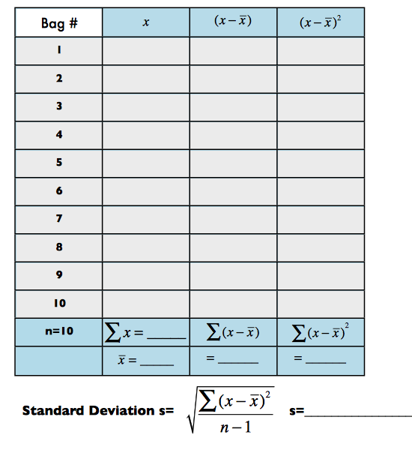
- Find the median, quartiles, and range.

Quartile 1:___________
Median: _____________
Quartile 3: ___________
Mode: _______________
Extension Questions:
- Figure out mean, standard deviation, and z-score for whole class data.
- Are you actually getting your money’s worth?
  - How can you calculate this?
- Graph using box and whisker plots.
- Are there any outliers?
- Are any of the weights considered unusual?

