Jennifer Lombardi
Addition and Subtraction of Vectors
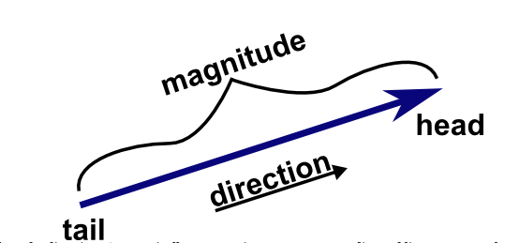
Name: Date:

Vector: a quantity having direction as well as magnitude, especially as determining the position of one point in space relative to another.

Head-to-Tail Method: When adding vectors together, always place the head of one vector to the tail of another.

GOOD EXAMPLES BAD EXAMPLES

Creating a vector: The first coordinate in the vector is the x-value of your second point, subtracted from the x-value of your first point. The second coordinate is the y-value of your second point, subtracted from the y-value of your first point. <$x_{2}$ -$x_{1}$, $y_{2}$-$y_{1}$>
Point A= (2, 5)
Point B= (5, 3)
<$x_{2}$ -$x_{1}$, $y_{2}$-$y_{1}$>
Vector = <3, -2>

Try making the vector using the points C= (5, 3) D= (3, 1)

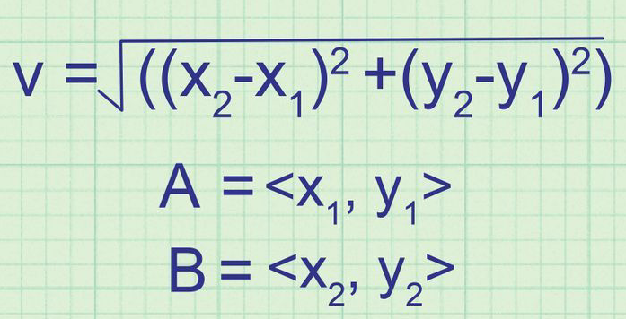
Finding the magnitude of a vector:
A= (2, 5)
B= (5, 3)
v=$\sqrt{({\left(5-2\right)}^{2}+{\left(3-5\right)}^{2})}$
v=$\sqrt{({3)}^{2}+{(-2)}^{2}}$
v=$\sqrt{(9+4)}$
v=$\sqrt{13}$
v$≈$3.605551

Try finding the magnitude of the vector you created using the points C= (5, 3) and D= (3, 1).

Adding vectors:  u=<3, -2>  v=< >  <$x_{1}+x_{2}$, $y_{1}$+$y_{2}$>  u+v=< > | Subtracting Vectors  u=<3, -2>  v=< >  <$x_{1}{-x}_{2}$, $y_{1}$-$y_{2}$>  u-v=< >

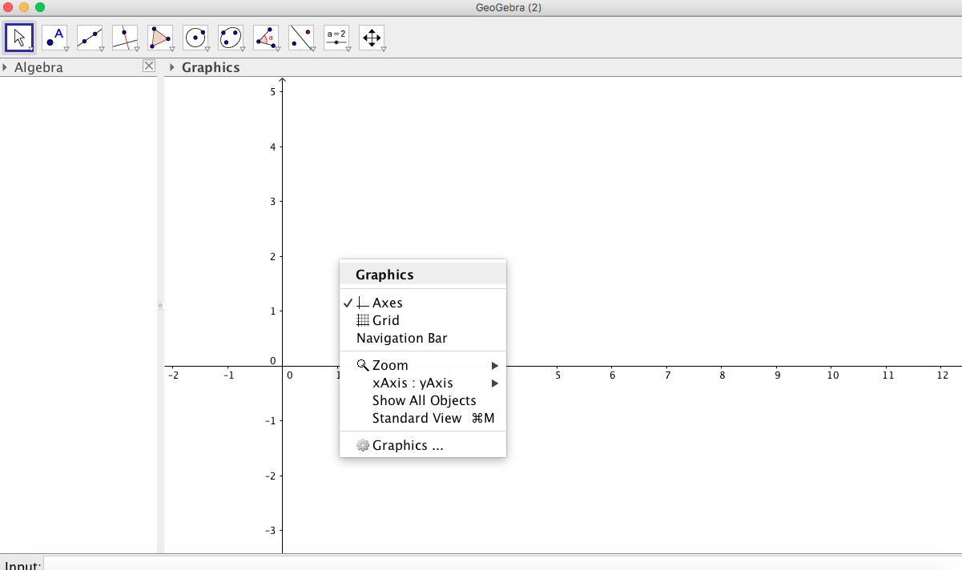
Vector addition using Geogebra:
- Start Geogebra and right click to display a drop down menu.
- From the drop down menu click grid to view grid.

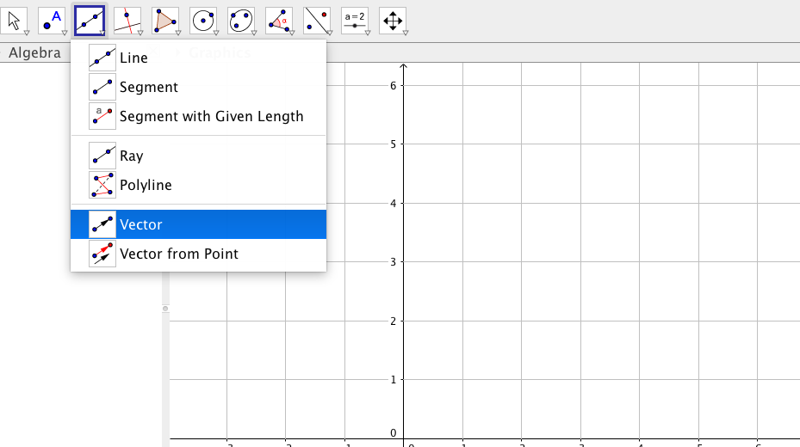
- Click on the third box from the left for the line drop down menu, and click on vector.

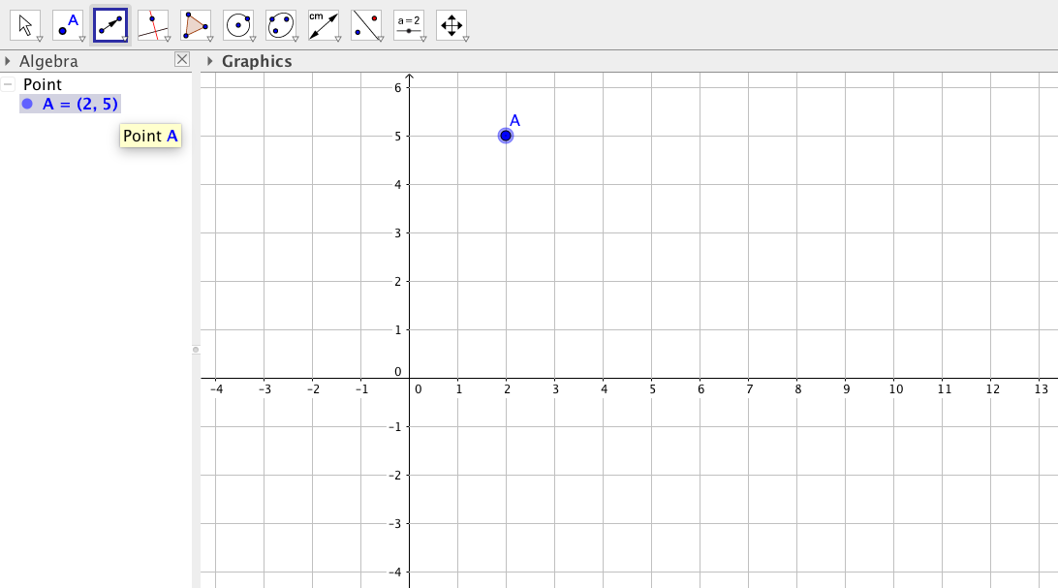
- Let’s use our Points A= (2, 5) and B= (5, 3) to make our first vector. Start with your mouse and find Point A and click. We just made point A the tail of the vector.

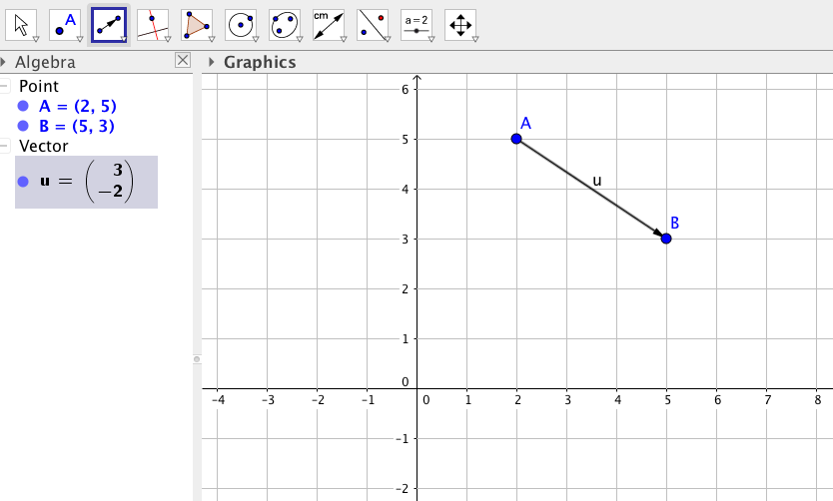
- Now find point B and click.
We just made point B the head
of the vector. This made a
vector in which Geogebra named
u.

- Now let’s make another vector using the points B= (5, 3) and C= (3, 1) from earlier. We start at the head of vector u which is also our point B (5, 3).
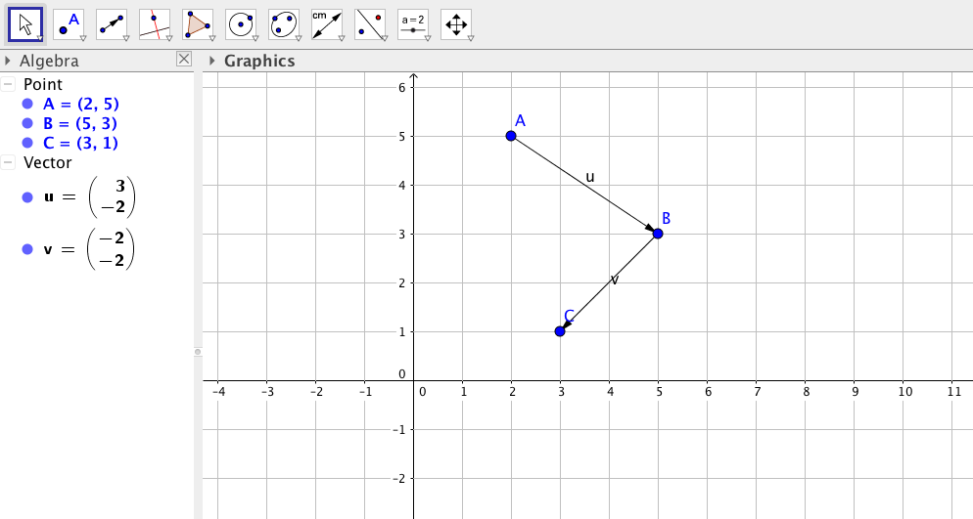

On the algebra side of the screen, find the vector v. v is the vector made by points B and C. Does the vector u have the same elements or direction that you found earlier?

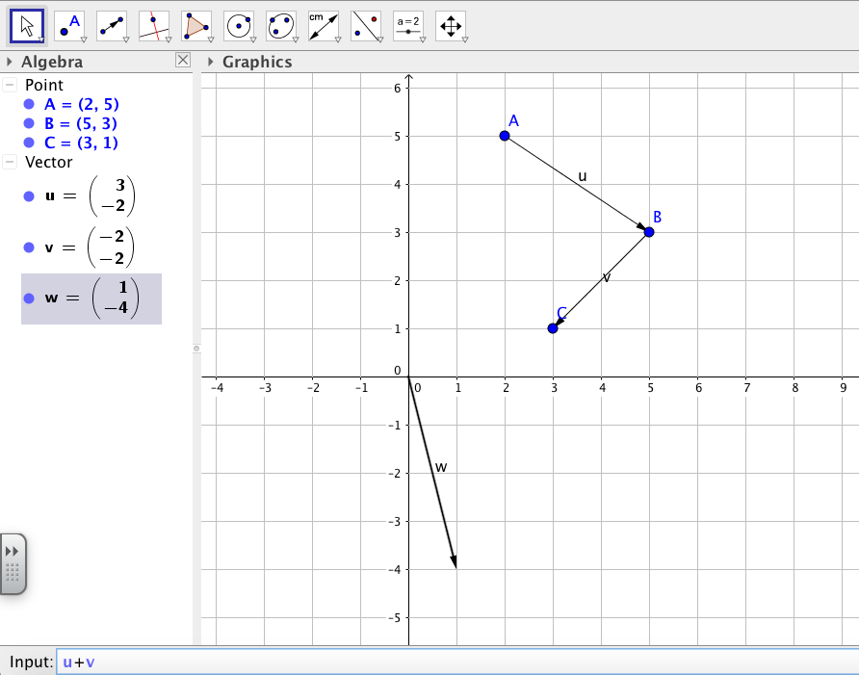
8. Now let’s add vectors u and v. Navigate the input bar on the bottom of Geogebra, type u+v, and hit enter.

The sum is a new vector in which Geogebra called w. Does the vector w have the same elements and direction that you had when you algebraically calculated u+v?

Vector w is the same vector going from point A to C. To verify this you can use the vector between two points tool (3rd box in from the left), and go to vector from point.
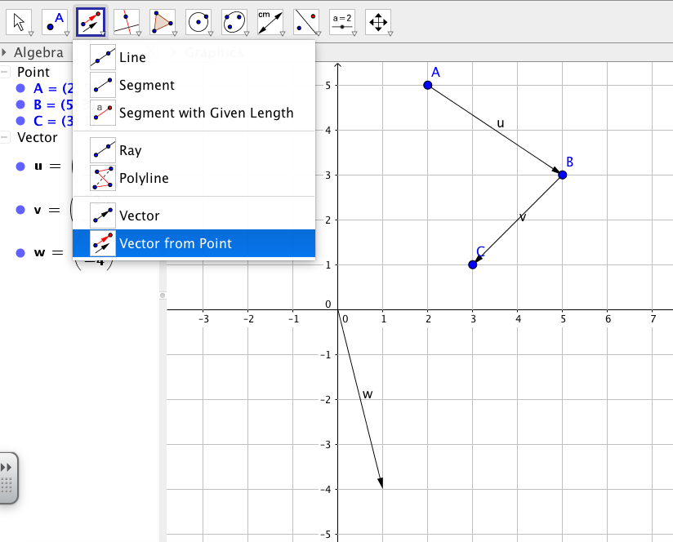

Click point A and then the vector w. This vector a, is the same vector as w.

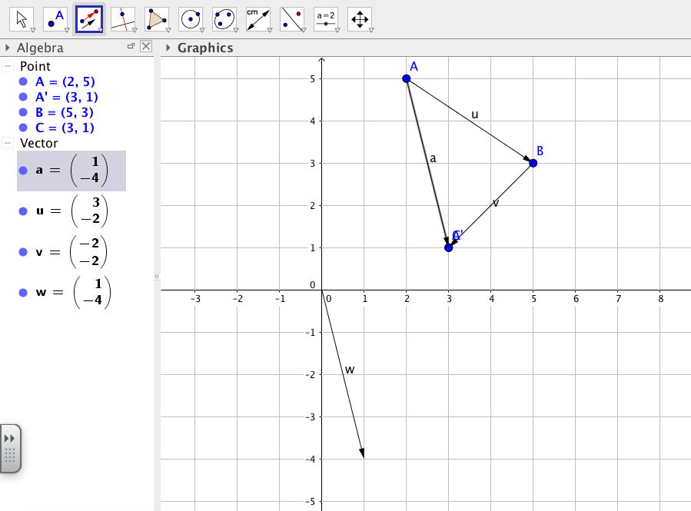

Vectors Subtraction using Geogebra:
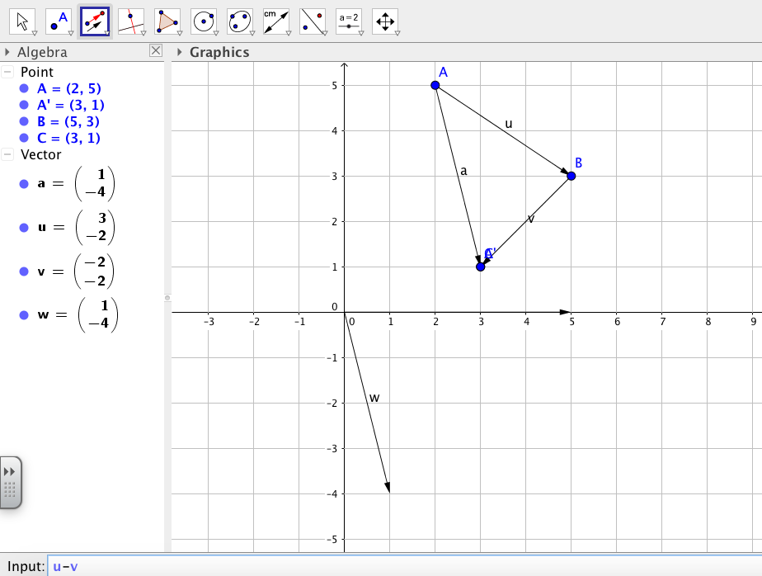
Let’s subtract vector v from u. To do this we type u-v in the input bar and click enter. This creates the vector b.

Is vector b the same vector that you found when you algebraically computed u-v?

Finding the magnitude of a vector on Geogebra: This is the same as finding the distance. Let’s find the magnitude of vector v. To do this, click on the distance or length tool (the 4th box from the right).

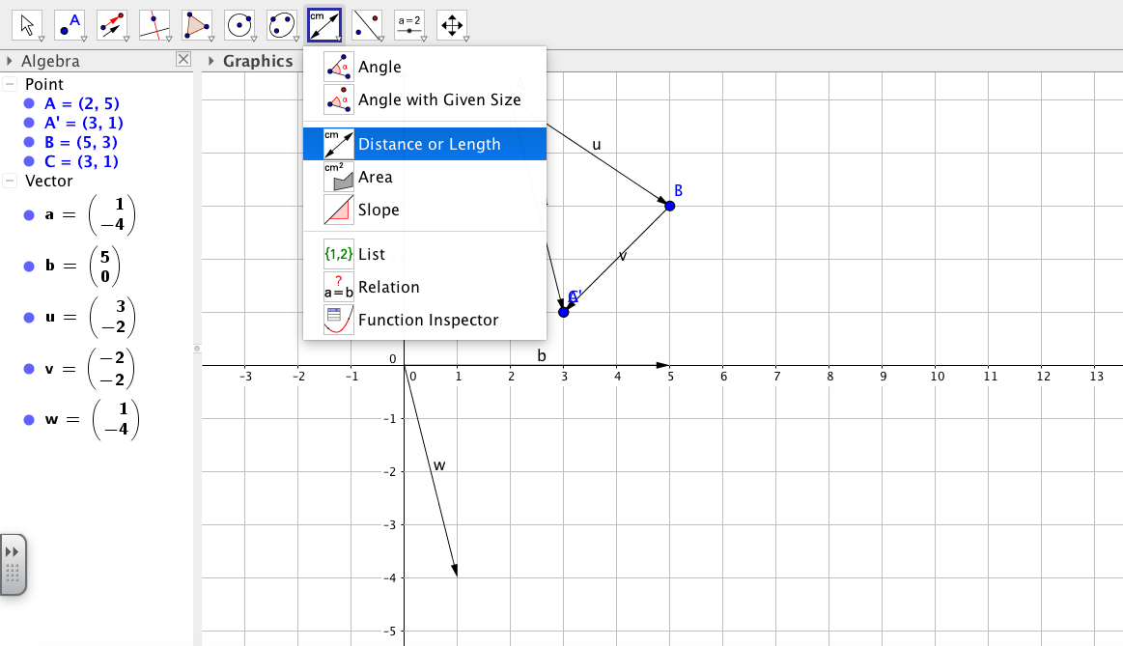

Using this tool, click on point B and then point C. 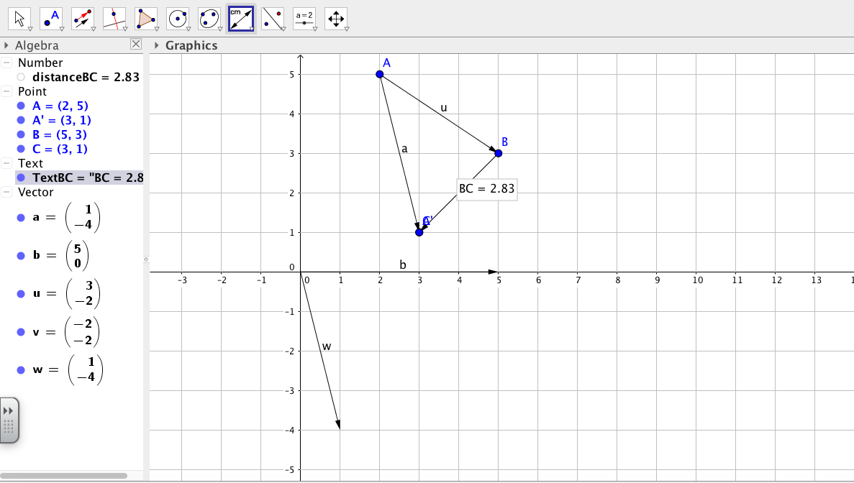
Geogebra calculated the magnitude of vector v for us. Is this magnitude the same as the one you algebraically calculated?

On your own, try creating the vector from points A= (2, 3) and B= (4, 7), and a vector from points B= (4, 7) and C (1, 5) using Geogebra. Next try adding and subtracting these vectors.

